**MPC Write-up Rubric points:**

**Model description:**

I have used the basic kinematic model which predicts the state of the vehicle for the next timestep based on the current time step values. The state vector contains the following elements.

x- Vehicle’s x position

Y- Vehicle’s y position

Psi- Vehicle’s Yaw angle

v- Vehicle’s speed

cte - cross track error

epsi - yaw angle error

The following equations are used to model the state elements

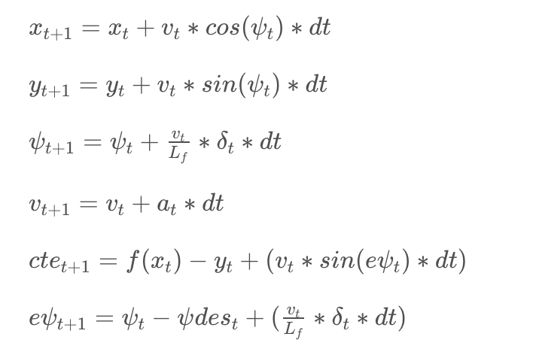

In the above equation a & del represents the actuator values (i.e. throttle and steering wheel angles)

**Time steps and Elapsed duration (N & dt) :**

I chose dt to be 0.1 (i.e. 100ms) as it will be easier to compensate the latency. At first I chose N as 10 second, as I wanted the simulation to be 1 second. The model behavior was very good with combination. The model behavior was erratic when I tried other values for Ex: N=2 and dt=0.1

**Polynomial Fitting and MPC Preprocessing**:

* At first I transformed the way points to vehicle domain as it will be easier to calculate the cte and psi (Line no : 103 to 108 main.cpp)
* Then I fitted the waypoint with a 3’rd degree polynomial (Line no : 113 main.cpp)
* I have reset the x, y & psi values to 0 before MPC simulation, as I am performing all calculations in vehicles domain (Line no : 116 main.cpp)

**Model Predictive Control with Latency**:

I handled the latency by using the actuator values from previous time step (i.e 100ms before) instead of the current time step values to estimate the state vectors for the next time step (Line no: 119 to 122 in MPC.cpp)